**Domain Research:**

The topic here for this project is going to about the mechanics in submarines and how they use them to submerge underwater and ascend to the surface. The thing they use on submarines are called ballast tanks and they basically allow the submarine to achieve the ability to submerge. How they work is that they can take in water from the surrounding body of water they are in and essentially increase their total mass to make the entire submarine heavy enough to start sinking to a certain depth underwater. When they ascend to the surface, the submarine releases the water with compressed air, thus decreasing the total mass of the submarine to allow buoyancy to float the submarine to the surface. As such, this picture shows how this works, showing the submarine in a state of diving, submerged, rising and when it’s surfaced, as well as the steps that it takes when taking in water.

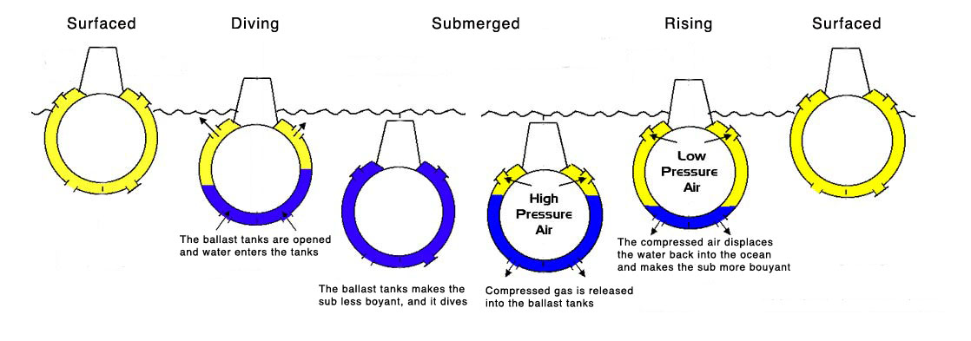

Source: https://followthelemur.files.wordpress.com/2011/10/risinglemur.jpg

Ballast tanks are also used in other things such as ships, except in those, they are used for other purposes such as balancing their ships out. For submarines, one submarine may have multiple ballast tanks, usually consisting of a system in which it has one main ballast tanks and several secondary tanks located at certain areas of the submarine. These secondary ballast tanks are often called “trim tanks”, these in conjunction with the ballast tanks are used to adjust the submarine’s depth when on the surface and underwater. This image shows a very general layout for how a submarine might have its ballast tanks laid out, as well as other parts of the submarine that are involved in the control of its movements.

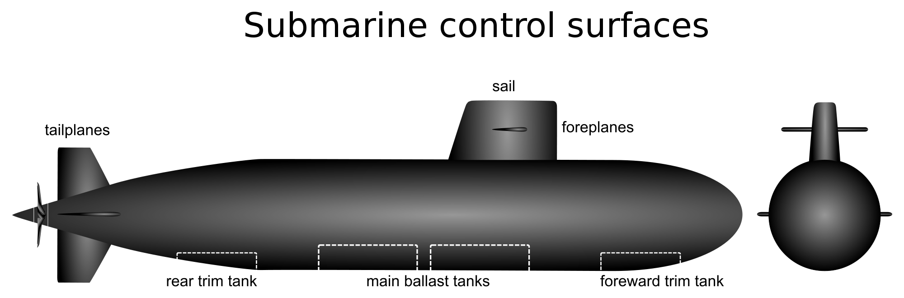

Source: <http://upload.wikimedia.org/wikipedia/commons/thumb/f/f2/Submarine_control_surfaces2.svg/2000px-Submarine_control_surfaces2.svg.png>

Going into details on how the ballast tanks allow the submarine to submerge underwater, Archimedes’ principle is used here to explain how it works. In general, when an object is immersed in any fluid, whether it is fully submerged or only partially, an upward buoyant force is applied to the object equivalent to the weight of the fluid that the object displaces when placed in the fluid. One can figure out how much an object displaces by using Newton’s Second Law for figuring out how much force is applied by gravity. Force of buoyancy is used here to calculate how much upward buoyant force is applied to the object, a higher buoyancy force than force of gravity means that the object will float to the surface while the opposite is true for a lower buoyancy force. Buoyance force takes into consideration the volume of fluid displaced by the object as well as the density of the fluid. Since we’ll be working with water, the fluid density will be around 1, depending whether or not it is seawater or fresh water. This image briefly shows the forces that applied to an object when submerged in a fluid.

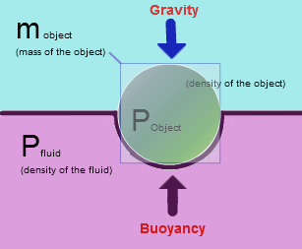

Source: images.tutorvista.com/cms/images/83/Buoyancy-force.PNG